**Index**

1. **Abstract**
2. **User Requirement**
3. **Screens**
4. **Note**

**Abstract:**

Your task is to create an Android app for N.A.S.A that will let the user browse through a list of images parsed from a JSON file.

Make a git repository for the project and send this to us once you are done. Write code incrementally; make multiple commits, just as you would in a real project.

**User Requirement:**

1. User should Scroll through list of photos
2. User Should be able to select a photo from the list to view more details
3. User Should be able to view Detailed article about the selected item
4. User should scroll through detailed cards.

**Screens:**

1. **Splash Screen**

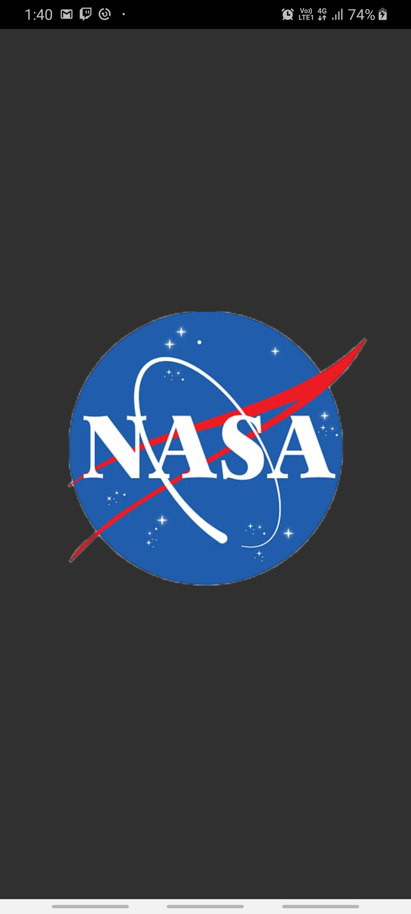

This is a simple welcome screen. User will stay for 5 seconds on this page . No functionality on this page

1. **Landing page/Image List page**

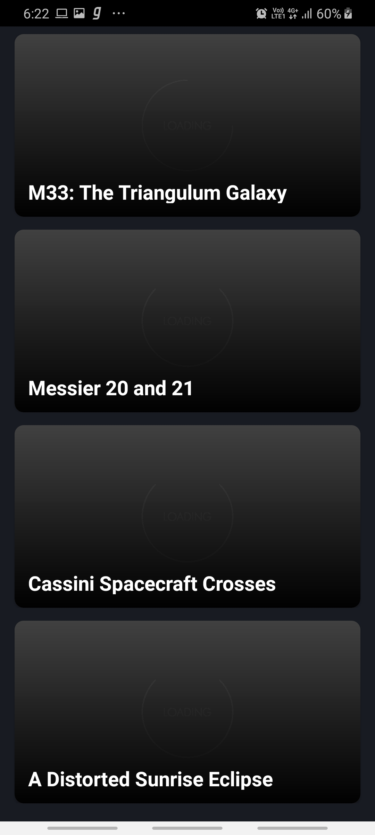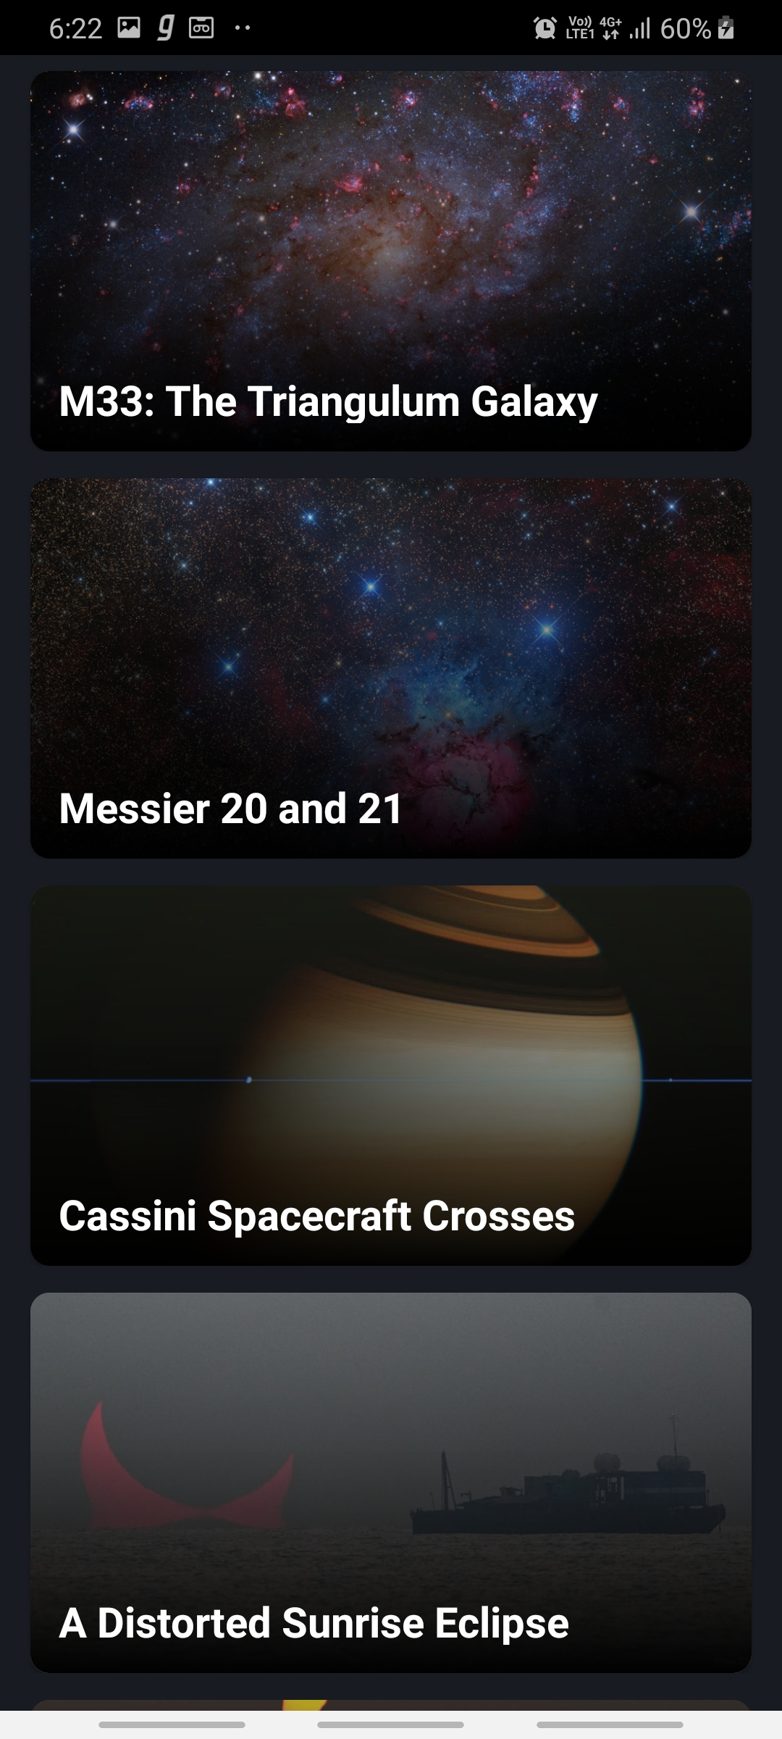

**\***Skeleton of the page *Populated data screen

This page will allow user to browse through images by scrolling vertically .

Items/Images would be loaded dynamically and sorted date wise.

No time constraints in this screen. User can select an item/image to view more details about it

1. **Detailed Information Screen**

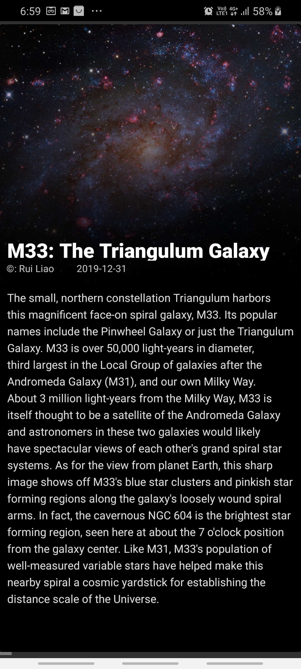

This Screen display all the information about the Image like Image, Title, Explanation, Copyright and Date. No time constraint on this screen.

User can read the explanation (scroll vertically if the article is bigger then the screen) and move through other detailed items by scrolling horizontally

**Note:**

Application do not have action bar or any type of navigation because of a single flow and no additional features specified in requirement list.